KARNATAK LAW SOCIETY’S

GOGTE INSTITUTE OF TECHNOLOGY

UDYAMBAG, BELAGAVI-590008

(An Autonomous Institution under Visvesvaraya Technological University, Belagavi)

**(APPROVED BY AICTE, NEW DELHI)**



*Course Project Report*

*On*

***Shopping mall Management System***

*Submitted in the partial fulfillment for the academic requirement**of*

***4th Semester B.E.***

***in***

***Information Science and Engineering***

***Submitted by***

Aryan Kulkarni 2GI19IS009

John Nixon 2GI19IS016

Pratik Desai 2GI19IS037

V Gopinath 2GI19IS056

**GUIDE**

**Dr. S.B Deshpande**

**2021-22**

|  |  |  |  |  |  |
| --- | --- | --- | --- | --- | --- |
| **Batch No.: 8** | | | | | |
| Seminar Title: Shopping mall Management System | Marks Range | **USN** | | | |
| **2GI19IS009** | **2GI19IS016** | **2GI19IS037** | **2GI19IS056** |
| Abstract (PO2) | 0-2 |  |  |  |  |
| Application of the topic to the course (PO2) | 0-3 |  |  |  |  |
| Literature survey and its findings (PO2) | 0-4 |  |  |  |  |
| Methodology, Results and Conclusion  (PO1, PO3, PO4) | 0-6 |  |  |  |  |
| Report and Oral presentation skill (PO9, PO10) | 0-5 |  |  |  |  |
| Total | 20 |  |  |  |  |

**Signature of Staff**

ABSTRACT:

The mini-project of ‘Mall Management System’ serves the purpose of making/managing sales and managing the employees of a mall. The scope of the project involves managing daily proceedings of all stores and daily overview of all the orders made. All such data along with the details of the Customer, Job Information of Employees, tenants etc are stored in the database. This data is further used while updating details of employees, customers, analysing employees

**ACKNOWLEDGEMENT:**

We would like to express deep sense of gratitude towards the college and our Professor Dr. S.B Deshpande for allowing us the opportunity to work on and present this project report and also for the able guidance and continuous support, he provided which helped to successfully compile and prepare our project and report.

**T**A**BLE OF CONTENTS:**

|  |  |
| --- | --- |
| **TITLE** | **PAGE NO.** |
| **1. Introduction** 1.1 Purpose 1.2 Scope 1.3 Definition 1.4 References 1.5 Developer’s Responsibilities: An Overview | 6 |
| **2. General Description** 2.1 Product Function Perspective 2.2 User Characteristics 2.3 General Constraints 2.4 Assumptions and Dependencies | 8 |
| **3. Specific Requirements** | 9 |
| 4. System Design 4.1 ER-Model (with all constraints justification – cardinality and participation) 4.2 Schema diagram (applying ER to Schema) 4.3 Output Snapshots | 10 |
| 5. System Implementation 5.1 Hardware and Software Platform description 5.2 Tools used | 17 |

1. **INTRODUCTION:**
   1. **- PURPOSE:**Admin Interface and Functionalities for a Mall Management System along with a Customer Portal for Customers to view the Products.

**1.2 - SCOPE:**

* The software can be used in Malls for managing all activities in a mall from an administrator point of view.
* Software is made for centralized information maintenance of Malls and all the data of employees and stores within.
* Central administrator has the control on all the activities, with respect to adding, deleting, modifying database information and accessing the information of tenants, customers, employees etc in the mall.
* Each Tenant has their own login. The Administrator, Manager and Employees will be guided to different functionalities based on their individual logins.
* Administrator is at the top of the privilege chain followed by the tenants for each of our departments
* Store Manager manages proceedings of his/her store.
* Our Database stores details of all the employees that includes their Personal Details and Contact Numbers, Job Information and Emergency Contact Details in case of any medical emergency.  
  Searching and functionalities based on the primary keys of their respective database (customer Id)

**1.3 – DEFINITIONS, ABBREVIATIONS AND ACRONYMS:**

• SQL – Structured Query Language

**1.4 – REFERENCES:**

• www.google.com  
 • www.stackoverflow.com  
 • www.w3schools.com  
 • [www.mysqltutorial.org](http://www.mysqltutorial.org)

**1.5 – DEVELOPER’S RESPONSIBILITIES:**

* Developer must provide simple and clean interface for user.
* Developer must follow all regulations and guidelines for development of the project.
* Technologies used by the developer must be latest and flexible.
* Developer must constantly build on this product.
* He/she must follow customer requirements and fulfil them.
* Developer must complete project and update requirements in less time
* Developer must look for customer feedback and suggestion and must

make changes accordingly

* Developer must see to it that the product he has built is usable on

various different platforms

* Developer must abstract key features and must provide

implementation for user

1. **GENERAL DESCRIPTION**
   1. **– PRODUCT FUNCTION PERSPECTIVE:**
      1. Our product looks to provide an administrator interface for managing a mall
      2. Product function perspectives include simple usability for management activities
      3. Creation, Updation and Deletion facilities
      4. Overall Summary analysis
   2. **– USER CHARACTERISTICS:**

* Users tend to show easy understanding of functionalities
* Some users are interested in additional functionalities
* Users tend to show knowledge of order management system
  1. **– GENERAL CONSTRAINTS :**
     1. Application is not hosted and hence does not have Online Support
     2. Maintaining the central sales record is less secure.
  2. **– ASSUMPTIONS AND DEPENDENCIES:**
     1. Basic Understanding of Order Management System from User Side
     2. Internet Connection for smooth flow
     3. Latest and Updated Files for complete project

1. **SPECIFIC REQUIREMENTS**

|  |  |
| --- | --- |
| **Mini world object** | **Requirement** |
| Mall | * Each mall has a separate name, location and a unique id. |
| Tenants | * Each mall has several tenants and each tenants has a unique tenant id, shop number and a separate shop name. |
| Customers | * There will be many customers in each tenant. * We collect several information about the customer like customer id, name, address, contact, E-mail id. * We collect this information for the verification purpose and also for the future references. |
| Order | * Each customer place one order and for each order we give order id, we compute the total price and store the information of a specific date and time at which the customer has placed the order. * We just want to keep track of the total number of orders by giving separate order id for each customer |
| Items | * Each order has several items and each items has a unique id, name, quantity and rate. * Each item has a separate id in order to get the exact name and price of that item. |
| Payment | * Each order has one payment method and each payment has a unique payment id and unique order id for verification and also for the future references * Each customer makes the payment in different mode, so we also collect information about the payment method. * After all these processes we compute the total amount which the customer has purchased. |

1. **SYSTEM DESIGN**
   1. **ER-Model (with all constraints justification –cardinality and participation)**

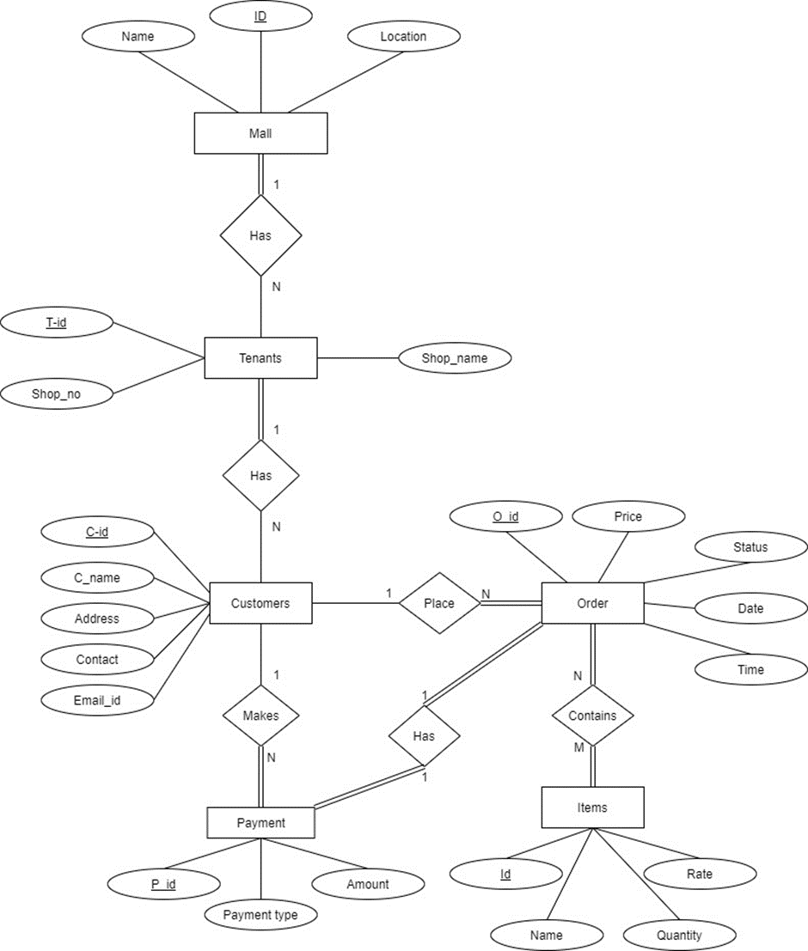

**4.2-Schema diagram (applying ER to Schema)**

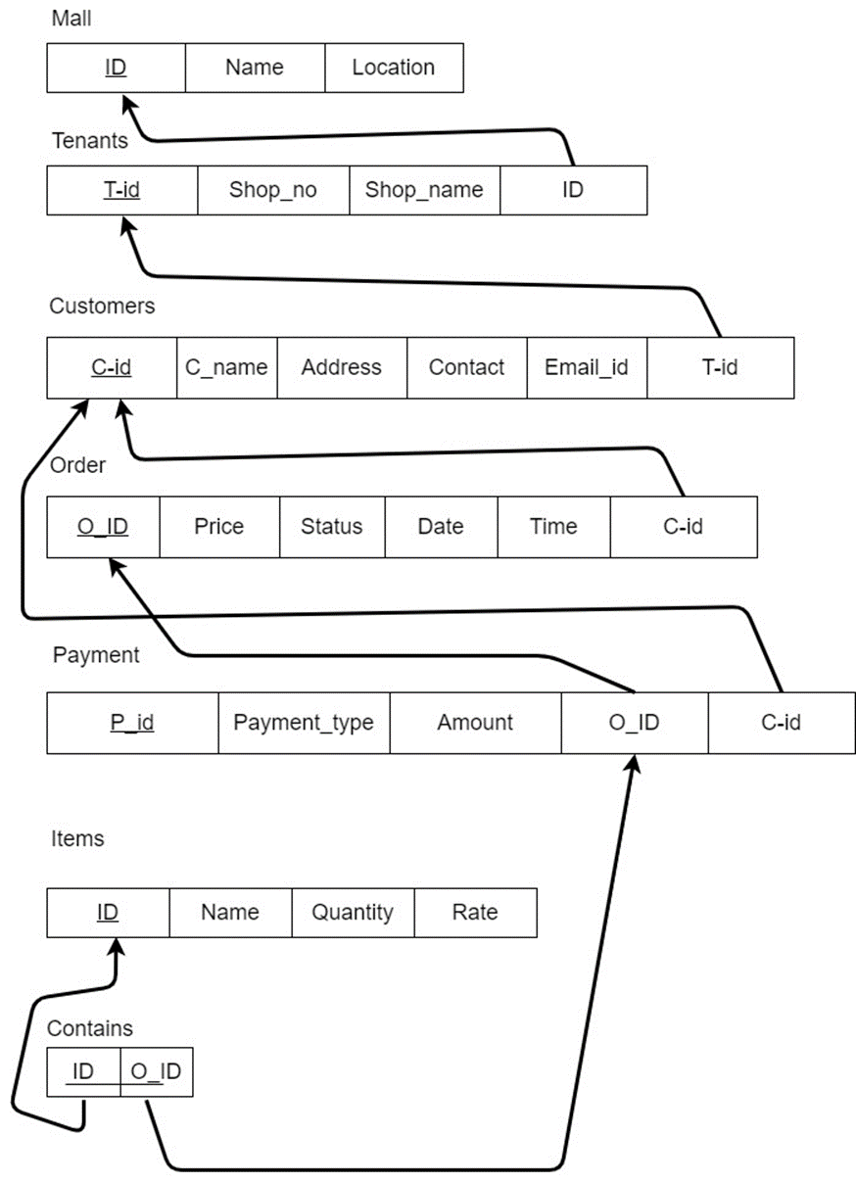

**4.3- USER INTERFACE SNAPSHOTS**

* **Login and Selecting tables**

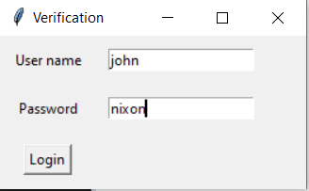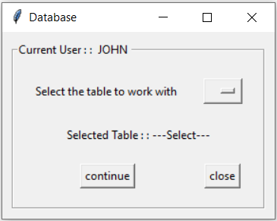

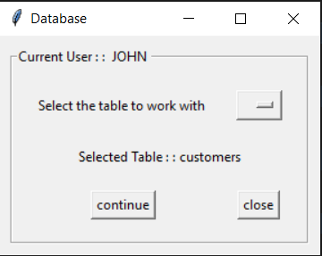

* **Entering Data**

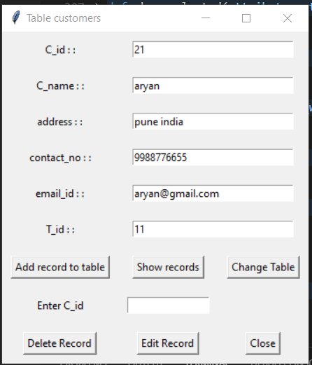

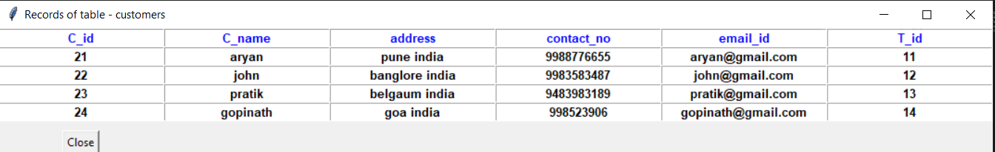

* **Viewing certain attributes**

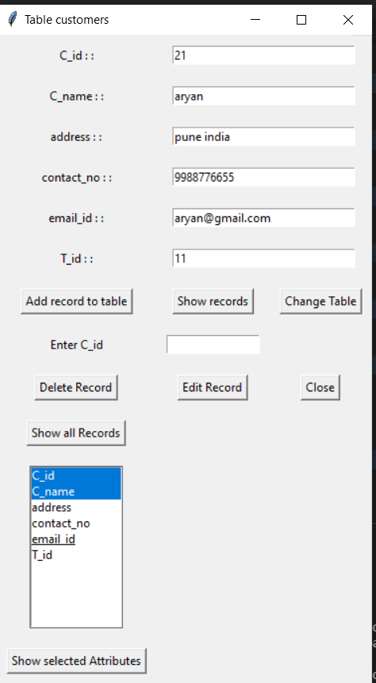 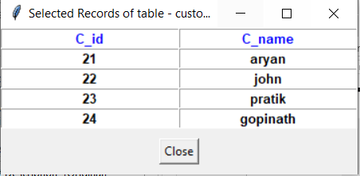

* **Updating Data**

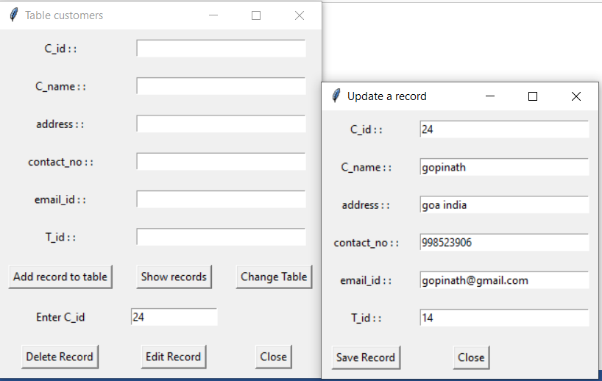

* **Deleting data**

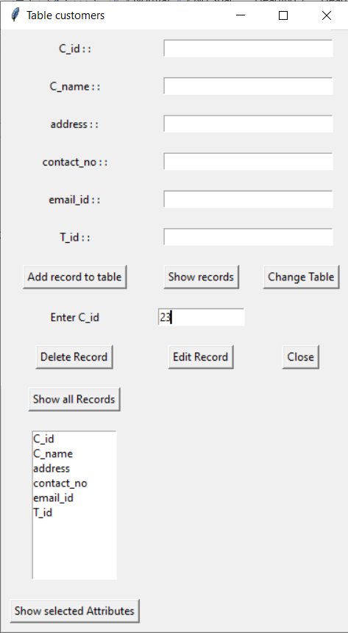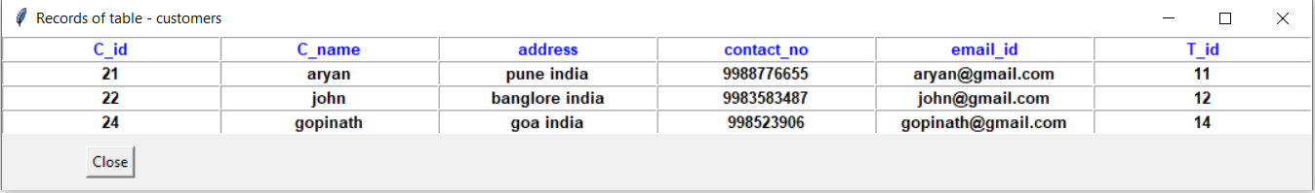

**5.1– HARDWARE / SOFTWARE PLATFORM:**

* + 1. Intel core I3/I5 Processor
    2. 4GB RAM, 1GB free hard drive space
    3. VS code , SQL LITE and a browser ( Google chrome, Brave, Microsoft edge)

**5.2– TOOLS USED:**

1. Dia
2. VS code
3. Python 3
4. SQL Lite

**CONCLUSION**

The three parts which are essential for this project are User interface, Creation of relational database and SQL engine.

The Project is entirely based on database management system concepts. The back-end use for project is SQL LITE and front-end is Python , HTML , CSS. The project is very feasible.

The software engineering concepts are used to implement the project. The requirement analysis is understood and done for this project